02nd May 2017

Monza Opens the options for all at FIA WTCC

Rounds 3 & 4 of the FIA World Touring Car Championship 2017 with YOKOHAMA as Official tyre supplier, took place at the weekend in Monza, Italy. Victories for Thed Björk and Tom Chilton at the Race of Italy means after the first four races, four drivers and four cars makes share the honours making it the most open and exciting Championship in recent years.

While Sébastien Loeb Racing driver Chilton edged Rob Huff – who had charged through from eighth on the grid – in a tense battle in the opening race, Björk had to catch and re-pass Tiago Monteiro for his maiden main race triumph after a slow start allowed the Honda man to get in front. The Swede’s success was also the first main rac victory for Volvo Polestar, which now moves ahead of Honda in the battle for the World Touring Car Championship for
Manufacturers having arrived in Italy level on points.

Meanwhile, Monteiro’s podium double ensures the Portuguese maintains his title advantage as he heads to the next race in Hungary leading new second-placed driver Björk by 15 points.
Like Monteiro, Huff was twice on the podium marking a reversal of fortune for Huff following a troubled season-opening Race of Morocco, it proved an afternoon to forget for Norbert Michelisz. The Hungarian works Honda driver was battling Mehdi Bennani for the opening race lead when contact put both drivers out. Bennani was penalised for his part in the incident and will serve a five-place grid penalty in the next race at the Hungaroring on the 14th May.

Tom Coronel started the opening race on the reverse-grid pole position but a fluffed getaway left him languishing in sixth at the finish behind Esteban Guerrieri, who appeared to lose out to Björk in a final-corner move until Björk picked up a one-second penalty for the incident, demoting him one place. American Kevin Gleason scored points on his WTCC debut with a meritorious ninth in the opening race, while Dániel Nagy bagged his first point in P10.

Nicky Catsburg scored a weekend-best fourth in the Main Race, one place ahead of Polestar Cyan Racing team-mate Néstor Girolami.

After the race, Tom Chilton (opening race winner) stated his delight with the result commenting, “It was a fantastic race. I’m so happy for the team. They’ve worked so hard and it couldn’t have happened at a better time as it’s nice to get a win early on in the season. Rob is British and knows how to fight hard on a race track. He’s a world champion and is never easy to keep behind. He’s also smart and knew if we started tangling too much we’d have the whole train right up our chuff and that makes it a whole lot harder around this circuit in particular with all the slipstreaming. We both pulled away and raced very well. I’m absolutely over the moon, just frustrated I didn’t finish the main race with a mechanical failure but that’s motorsport.”

For his part, Thed Björk (main race winner): stated “For me it was probably one of my best races ever. I felt completely relaxed and just had to perform and use what I had in the car and from the team and it felt really good. I just have to practice the start a bit but after that I was chasing Tiago. I knew I had to be on his tail to see if something happens but I got the pass early on. I had the speed, it was an amazing race to drive here at Monza and I was just enjoying it, I’m really happy.

The next race will be at the Hungaroring on the 14th May.

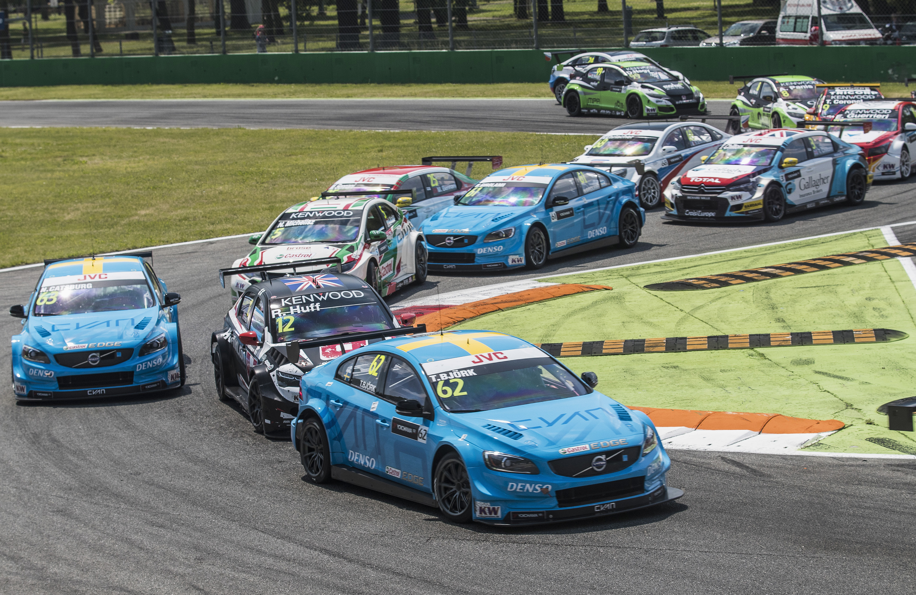
Bjork leads in WTCC Monza

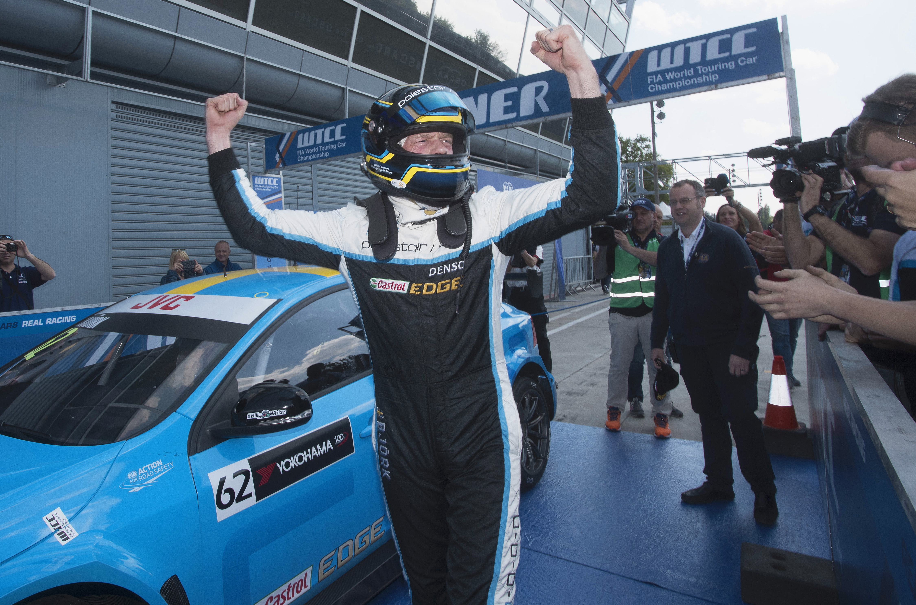
Bjork delighted to win

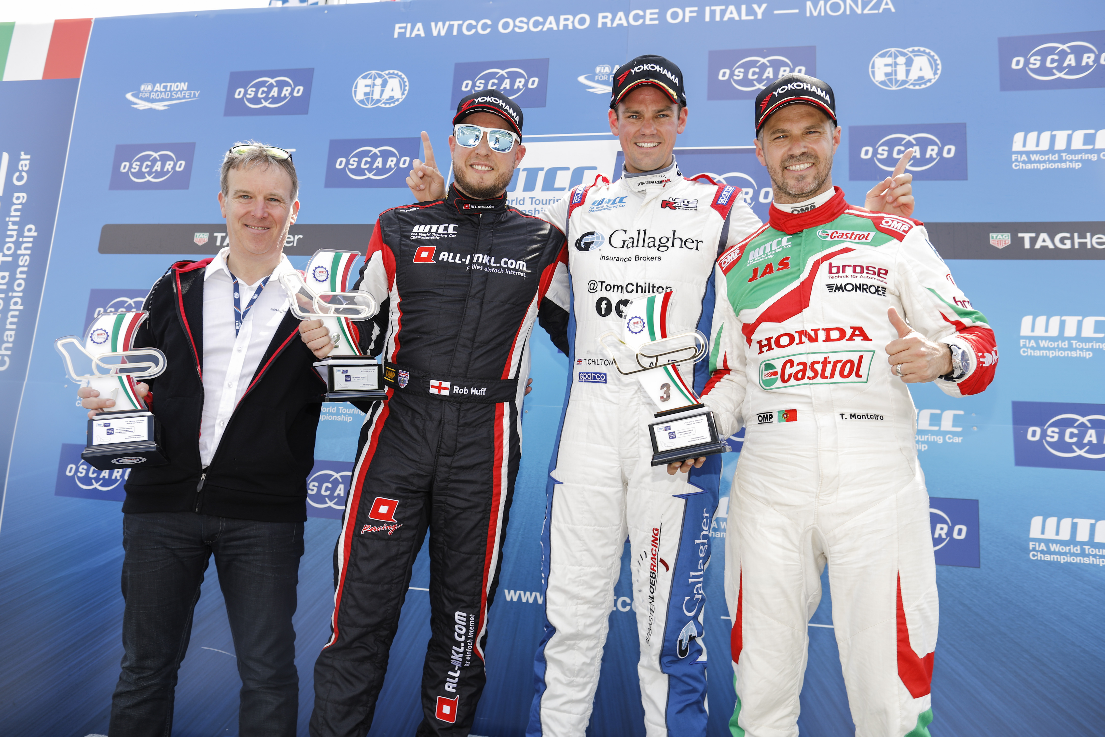
Tom Chilton is all smiles at the top of the podium

